AI ASSISTED CODING
ASSIGNMENT-7.2
Name : M.Sai Charani
HT.NO : 2303A52192
BATCH : 34
Task 1 – Runtime Error Due to Invalid Input Type
• A Python program accepts user input and performs arithmetic
operations. However, the program throws a runtime error because
the input is treated as a string instead of a numeric type.
Example (Buggy Code):
num = input("Enter a number: ")
result = num + 10
print(result)
• Task:
Use AI tools to identify the cause of the runtime error and modify
the program so it executes correctly.
Expected Output -1:
• AI converts the input to the appropriate numeric type and
eliminates the runtime error.
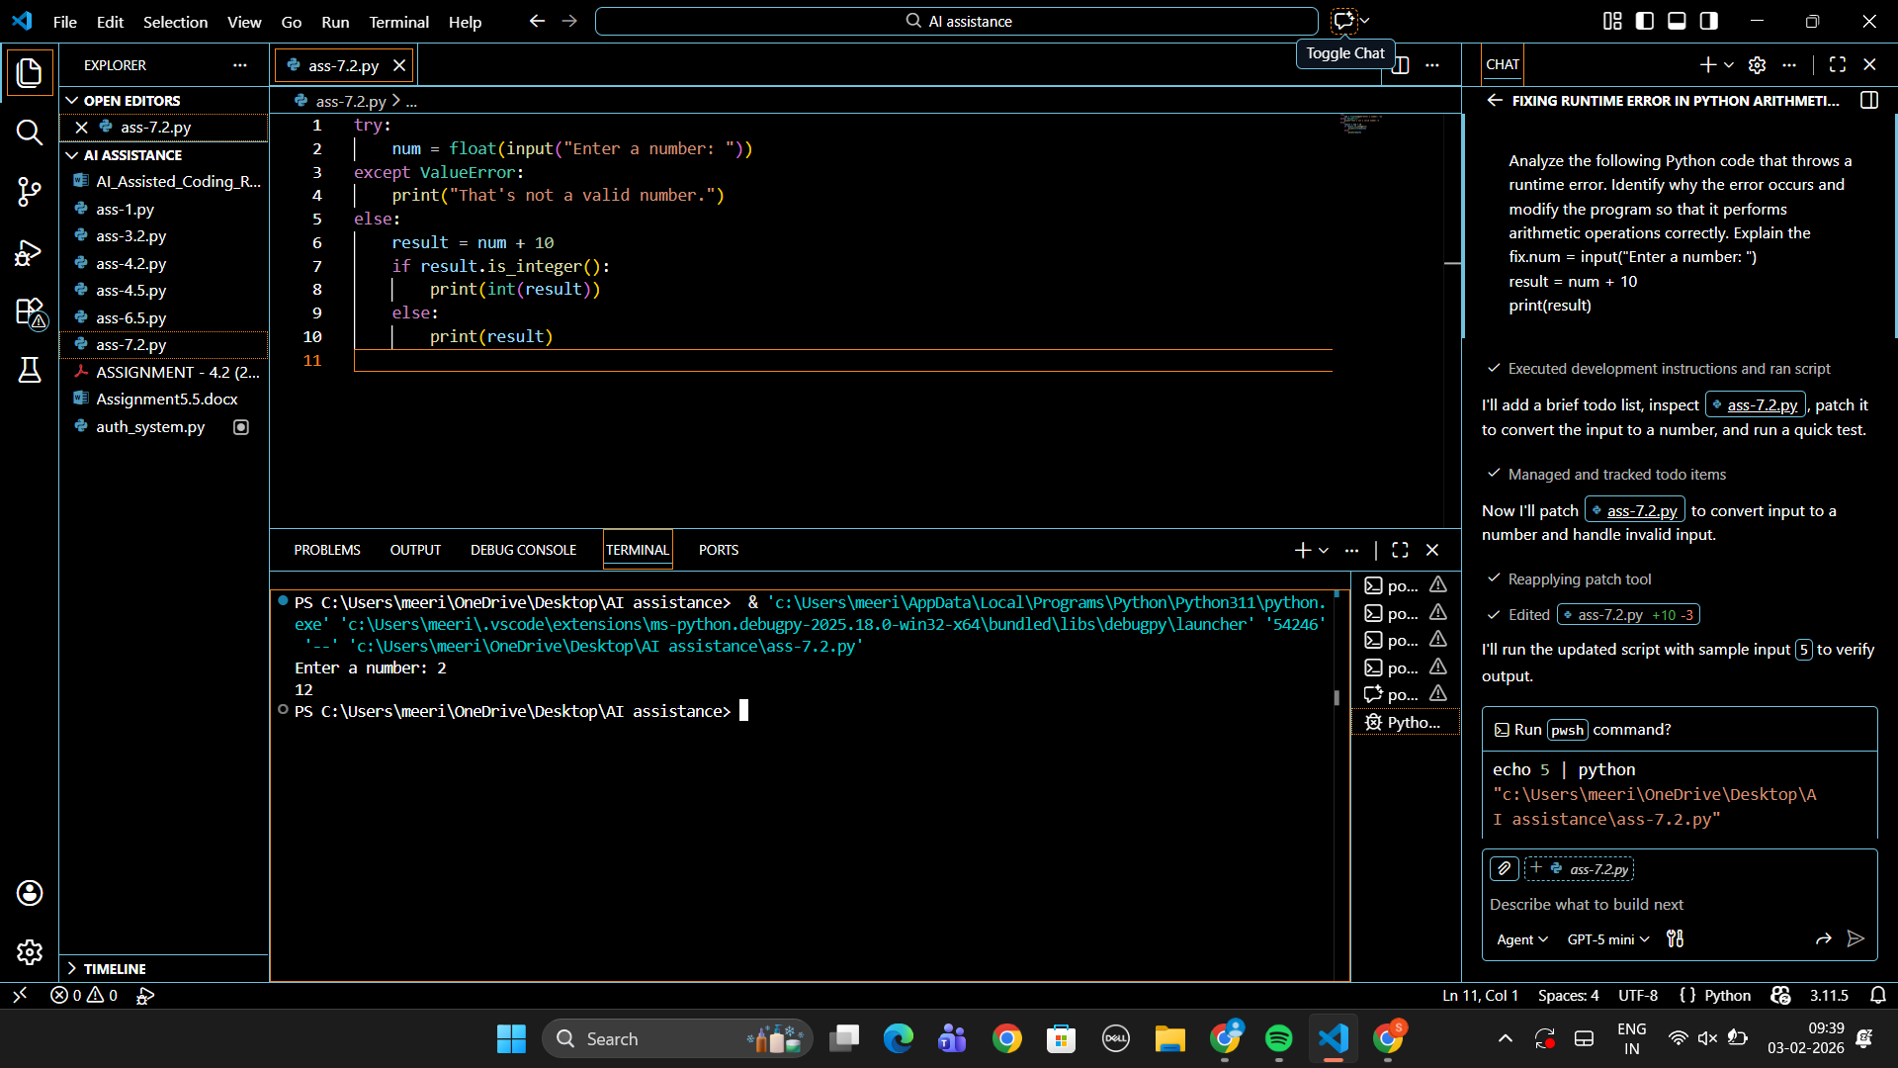

Task 2 – Incorrect Function Return Value
A function is designed to calculate the square of a number, but it does not
return the computed result properly.
Example (Buggy Code):
def square(n):
result = n * n
Task:
Use AI assistance to analyze the function and ensure the correct value is
returned.
Expected Output -2:
AI fixes the missing return statement and the function returns the correct
output.
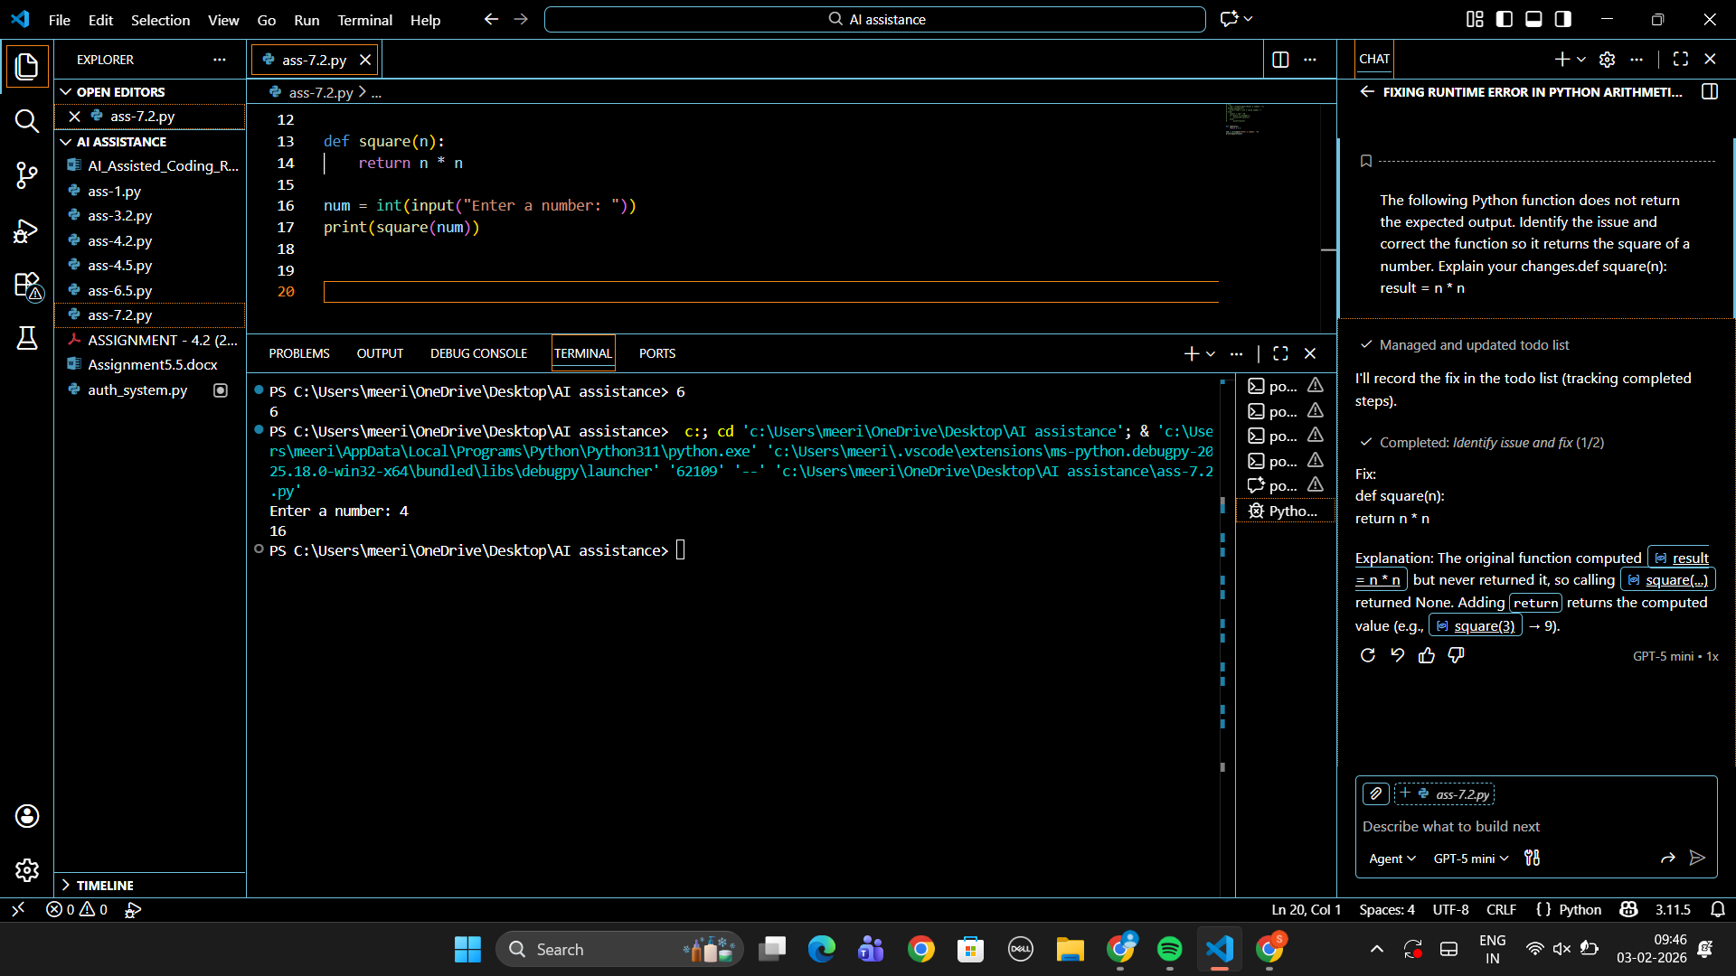

Task 3 – IndexError in List Traversal
A Python program iterates over a list using incorrect index limits,
causing an IndexError.
Example (Buggy Code):
numbers = [10, 20, 30]
for i in range(0, len(numbers)+1):
print(numbers[i])
Task:
Use AI to identify the incorrect loop boundary and correct the iteration
logic.
Expected Output -3:
AI fixes the loop condition and prevents out-of-range list access.
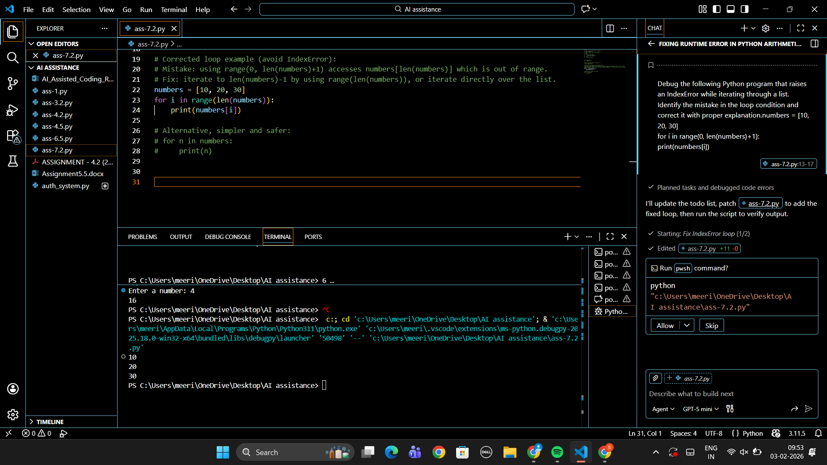

Task 4 – Uninitialized Variable Usage
A program uses a variable in a calculation before assigning it any value.
Example (Buggy Code):
if True:
pass
print(total)
Task:
Use AI tools to detect the uninitialized variable and correct the program.
Expected Output -4:
AI initializes the variable correctly before it is used
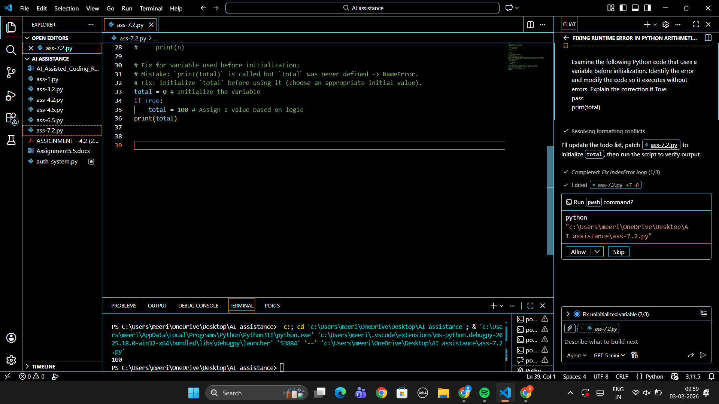

Task 5 – Logical Error in Student Grading System
A grading program assigns incorrect grades due to improper conditional
logic.
Example (Buggy Code):
marks = 85
if marks >= 90:
grade = "A"
elif marks >= 80:
grade = "C"
else:
grade = "B"
print(grade)
Task:
Use AI to analyze the grading conditions and correct the logical flow.
Expected Output -5:
AI corrects the conditional logic so grades are assigned accurately.
